Time Sensitive---Please Correct Immediately

To
Cc
Bcc
Subject | Time Sensitive---Please Correct Immediately
Greetings,

We are reviewing attendance rosters. Please correct the following error(s):

Course:

Error: No attendance recorded for the following student(s):

Instructions:

- Enter attendance on the attendance tab (P-present status) on the date the student submitted their first assignment for online rosters or on the first day they came to class for face-to-face or Zoom rosters. (After the first P-present status has been recorded, you will mark the student with a P-present or A-absent status for each subsequent assignment due date for online rosters, and mark P-present, A-absent, or L-late statuses for each subsequent face-to-face or Zoom meeting rosters.)

- Flag any student who did not attend by the census date as a 'No Show.' Enter an LDA or 'No Show' flag for any student who dropped. (Remember to block 'No Shows' and drop students in Blackboard!). To add a 'No Show' flag after attendance certification, please go to the Faculty section of Self Service. Choose the course in question. Select the Grading tab at the top. The main grading page will display. Click the final grade tab and scroll down to the student in question. Next to the student's name there will be an LD field and then a 'No Show' box. Check the box to flag a student as having never attended.

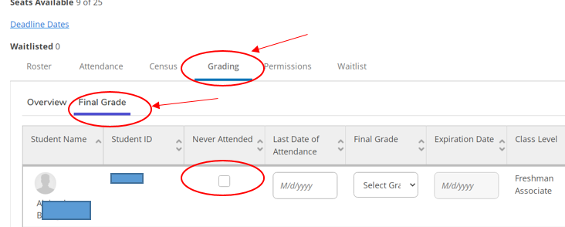

Disallowed Code

To | Katherine Preston
Cc
Bcc
Subject | Time Sensitive---Please Correct Immediately
Greetings,

We are reviewing attendance rosters. Please correct the following error(s):

Course:

Error: has an "E-Excused Absence" entry for Jan 12, 2026

Instructions:

- Enter attendance on the attendance tab (P-present status) on the date the student submitted their first assignment for online rosters or on the first day they came to class for face-to-face or Zoom rosters. (After the first P-present status has been recorded, you will mark the student with a P-present or A-absent status for each subsequent assignment due date for online rosters, and mark P-present, A-absent, or L-late statuses for each subsequent face-to-face or Zoom meeting rosters.)

- Flag any student who did not attend by the census date as a 'No Show.' Enter an LDA or 'No Show' flag for any student who dropped. (Remember to block 'No Shows' and drop students in Blackboard!). To add a 'No Show' flag after attendance certification, please go to the Faculty section of Self Service. Choose the course in question. Select the Grading tab at the top. The main grading page will display. Click the final grade tab and scroll down to the student in question. Next to the student's name there will be an LD field and then a 'No Show' box. Check the box to flag a student as having never attended.



